LAB 8
- Write a program to reverse a string without using built-in reverse functions.

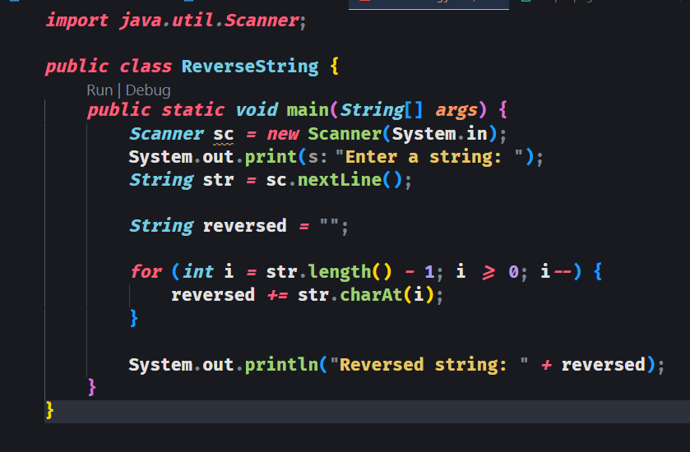
OUTPUT:
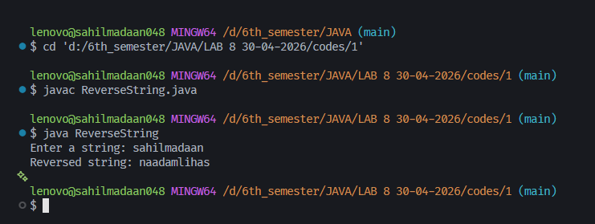

OUTPUT:

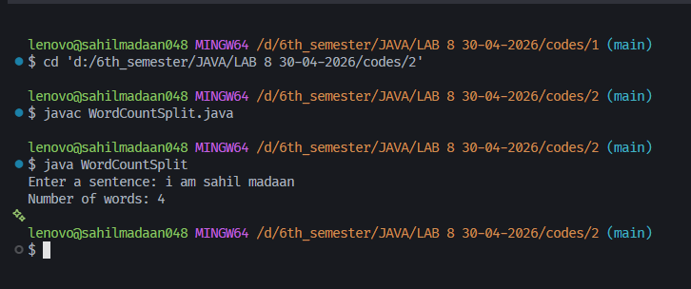
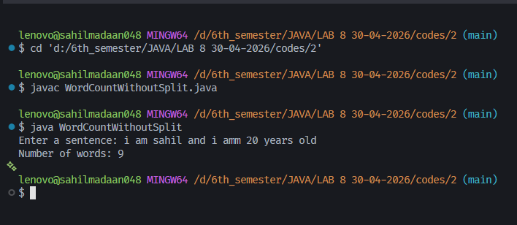

LAB 8
- Write a program to count the number of words in a string (with and without split() method).
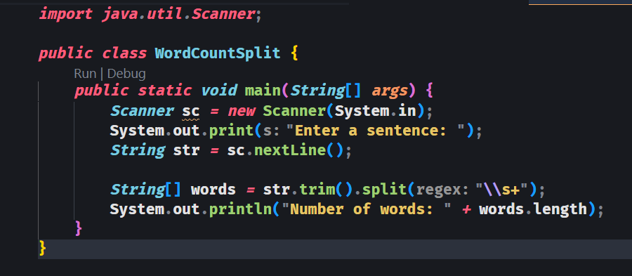
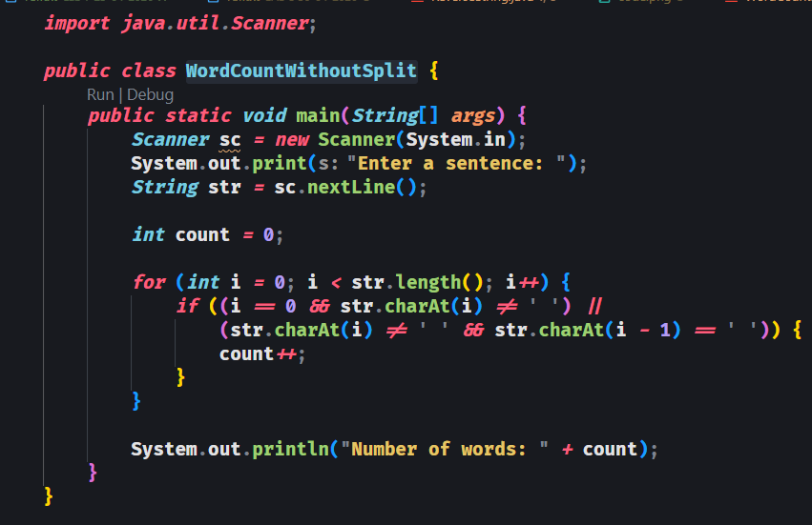

LAB 8
- Create a program to remove duplicate characters from a string.
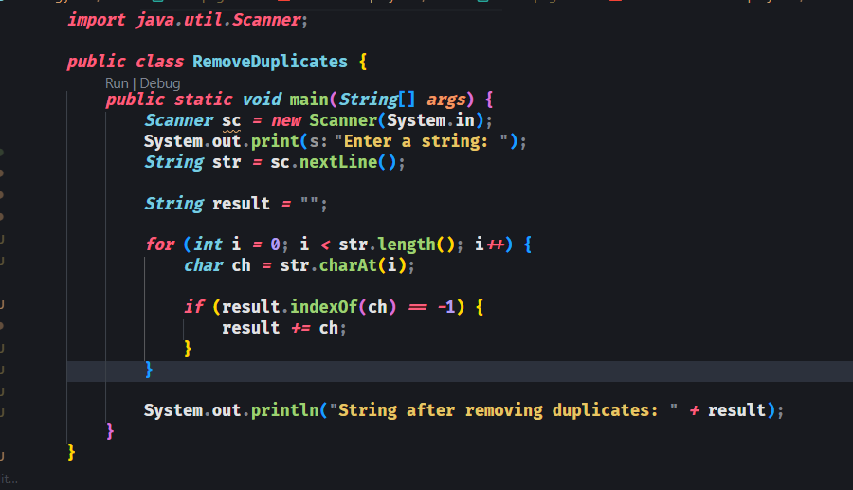
OUTPUT:
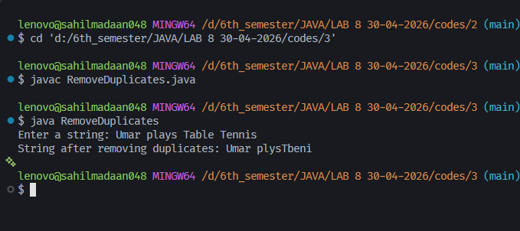

LAB 8
- Write a program to find the frequency of each character in a string.
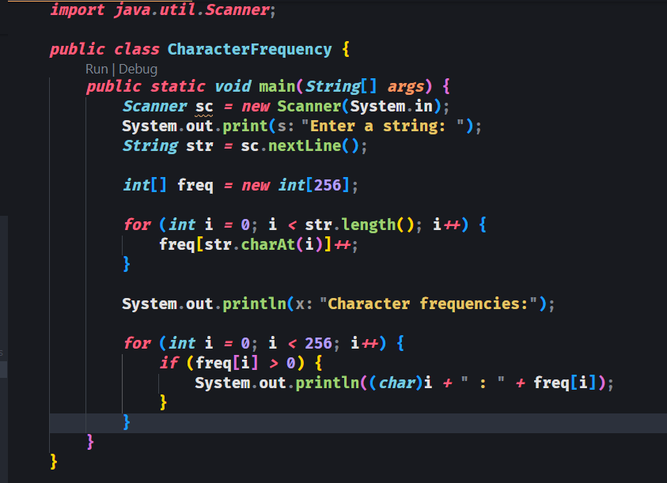
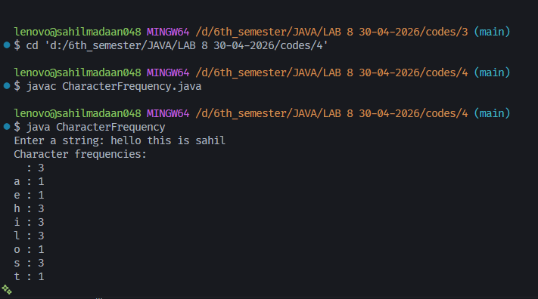
OUTPUT:

LAB 8
- Create a program to capitalize the first letter of each word in a sentence.
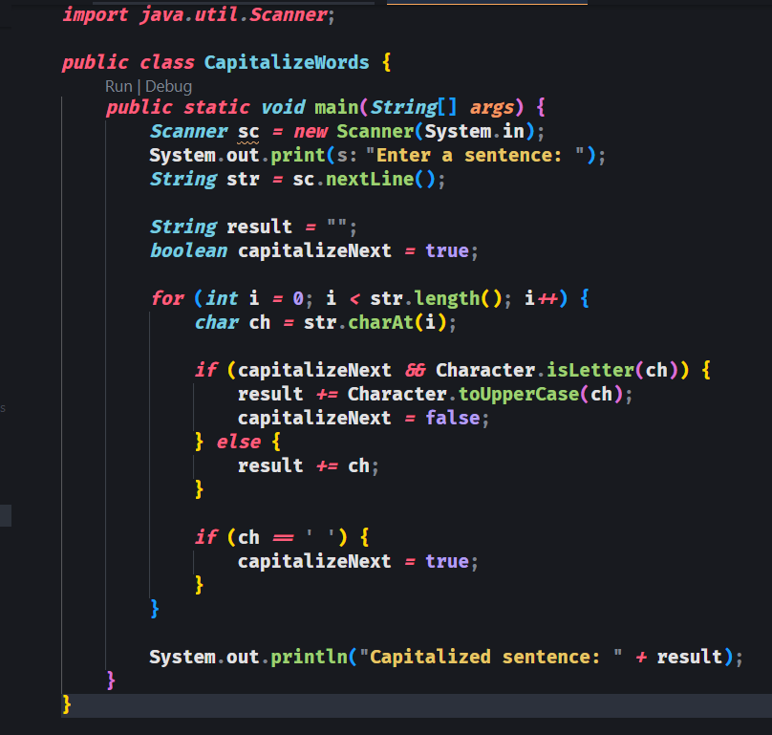
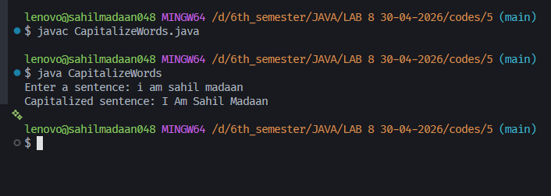
OUTPUT:

LAB 8
- Write a program to create three strings and compare each pair of strings using the compareTo() method. Display the numeric values returned by each comparison.

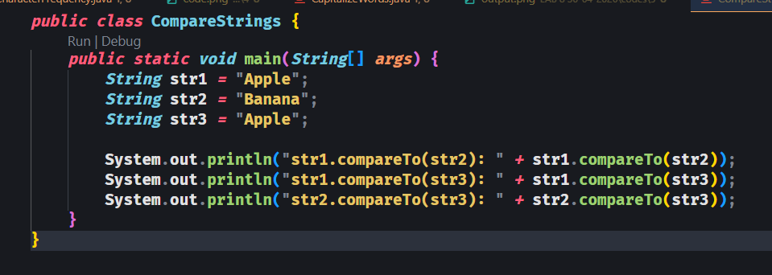
OUTPUT:
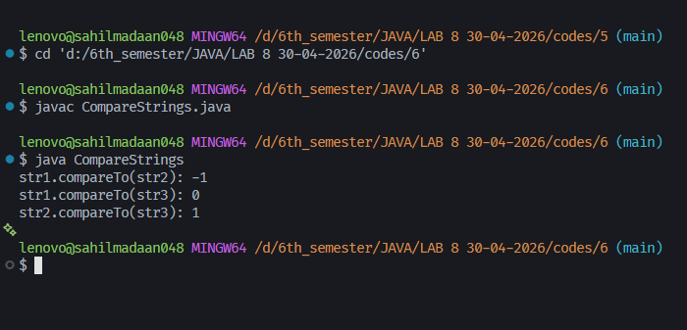

LAB 8
- Write a program to implement your own version of equals() method for string comparison (without using equals() or compareTo()).
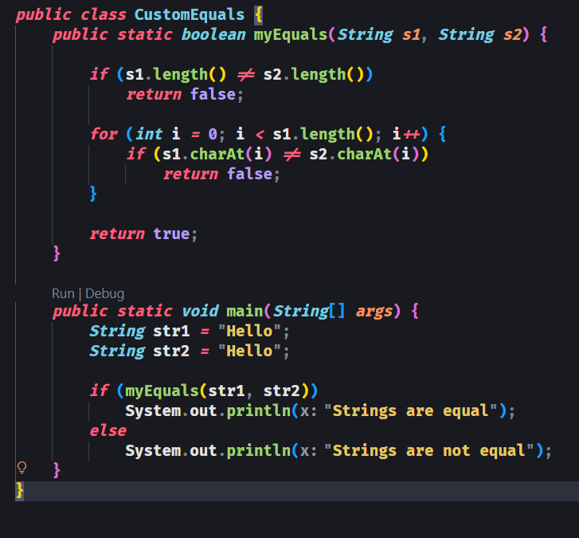
OUTPUT:
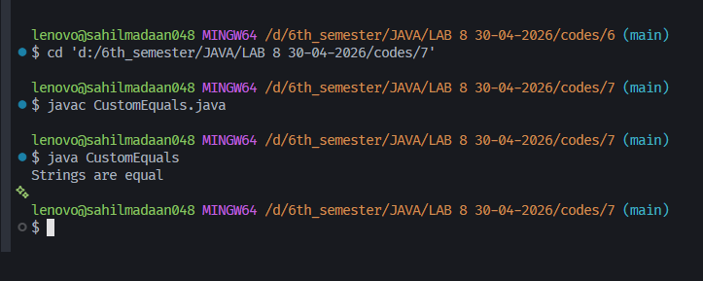

LAB 8
- Write a program to compare one string created using a literal and another using the new keyword using both == and equals().

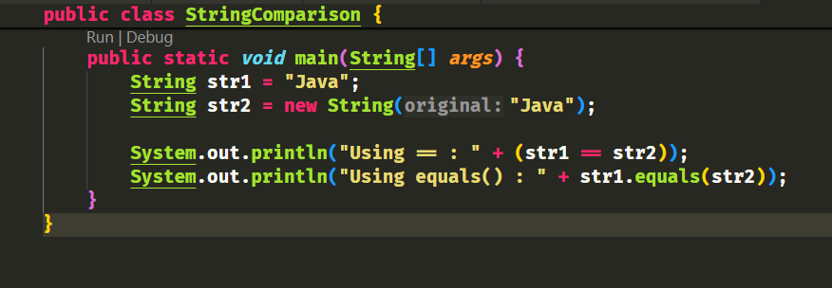
OUTPUT:
